CASE REPORT:

A possible neurological explanation for the “swimmer puppy syndrome”.

- A CASE STUDY-

Maja Guldborg, DVM

ABSTRACT:

Introduction: Swimmer puppy is a well known syndrome all over the world. Less known is the cause of the syndrome. It almost always occurs in litters of small size, only one puppy in the litter is affected, and that puppy is usually overweight. Lots of breeders and veterinarians have made the observation that the affected puppy is nursing with the head to the same side most of the time. The puppy remains in sternal recumbency. It is unable to get up or move around, and as a result it becomes more and more flat in the chest (pectus excavatum).

The hypothesis is, that the syndrome is either inherited and/or is a type of neuromuscular developmental problem in neonatal dogs.

The aim of this study is to look closer at the functional neurology to see if there are specific neurological circuits which can explain the cause of the “swimmer puppy syndrome”.

Clinical features: Daisy is a chocolate female Labrador retriever puppy. Of the only four puppies in the litter, two of them died in the birth. The owner observed at Day 10 that Daisy had a head tilt to the right and swimmer symptoms.

The overall symptoms were head tilt to the right, lateral strabismus of the left eye and the lack of strength in the extensor musculature, making the puppy lying flat on the chest. It was paddling with the front legs while the hind legs were trailing out behind with little or no movements. The puppy looked like a turtle and was unable to get up and turn around.

After having the puppy diagnosed as a swimmer puppy on day 12, the owner talked to another breeder with a lot of experience. She instructed the owner to do some physiotherapy with the puppy.

The owner succeeded in getting the puppy up after 8-10 days, but the head tilt and lateral strabismus was unchanged.
On the 23rd day the owner took the puppy to a veterinary ophthalmologist because she was afraid the puppy was blind.
The puppy was able to see, but as the ophthalmologist suspected a neurological issue, he referred the puppy to our clinic.

Intervention and outcome: Daisy was 28 days old when she was presented to our clinic. The owner wanted us to evaluate whether biomechanical problems were creating her head tilt and if there was a possible neurological cause for her lateral strabismus.

A thorough neurological and biomechanical examination was performed including palpation of the muscles of the entire body and evaluation of the range of motion of the joints in the extremities and spine.

There was marked decreased range of motion in the neck, specifically in the C1-C2, C3-C4 and C6-C7 areas.

The puppy received chiropractic treatment to increase the range of motion of those joints. The owner was instructed on specific exercises both to stimulate the medial rectus muscle, the extensor musculature in the body in general, and to keep the joints movable.

The head was symmetrical the day after the treatment (i.e no head tilt) and the lateral strabismus disappeared after 8-10 days.

Conclusion: Anything that may affect the vestibular apparatus, like a head tilt, might cause a decreased stimulation of the vestibulospinal and the reticulospinal tracts. Those are the “extensor tracts” responsible for the communication between brain and extensor musculature. Therefore the aim of the treatment of swimmer puppies is to stimulate their extensor tracts and to attempt to determine the cause of the unstimulated extensor tract.

Key Indexing Terms: Head tilt, swimmer puppy, pectus excavatum, strabismus.

INTRODUCTION:
Swimmer puppy syndrome is a disorder found in puppies from small litters. There is usually only one affected puppy and it tends to be obese. Depending on the severity and the owners’ experience, they observe the symptoms from 1 to12 days post partum.
Initially the owners observe that the puppy is continually lying flat on the stomach with the legs just circling a little and with little forward motion. The puppy is unable to turn around and/or get up. It appears that most affected puppies turn their head consistently to one side when they are nursing.

After searching the veterinary literature, it becomes clear that the cause of the syndrome is unknown. There are an abundance of observations leading to the hypothesis that the syndrome might have a genetic cause and/or that it is a type of delayed neuromuscular development. Furthermore some observers speculate about environmental factors, such as viruses, bacteria, and finally some suggest that hard, flat, slippery surfaces where the puppies move around might be the cause.

It also appears that there is no specific treatment. As the condition worsens, there seems to be no choice but euthanasia.
The best results are achieved when the owner does specific gymnastic exercises with the puppy and keeps turning it around to prevent it from just lying prostrate. The longer the puppy lies in sternal recumbency, the worse the pectus excavatum becomes.

Let us take a look on the period from the puppy is newborn until it is up walking around. Which neurological circuits are involved in that phase?

When a puppy is between 1 and 12 days old it develops the secondary lordotic curvature in the neck. At the same time the puppy will try to lift the head and move around. When the head is moved, the vestibular apparatus is stimulated. The vestibular apparatus consists of the utricle, the saccule, and three semicircular canals.

The Utricle and the Saccule Detect Linear accelerations.
The utricle and the saccule are expansions in the membranous labyrinth. Each contains a macula, which is a patch of hair cells overlain by a gelatinous sheet, called the otolithic membrane (Wilson-Pauwels, et al. pg. 146, 2002). Crystals of calcium carbonate called otoconia are imbedded in the otolithic membrane. The otoconia make the otolithic membrane considerably heavier than the structures and fluids surrounding it; thus, when the head tilts, gravity causes the membrane to shift relative to the sensory epithelium (Purves, et al. pg.318, 2004).

The main functions of the utricle and the saccule are to detect the position of the head and the movements of the head relative to gravity (Wilson-Pauwels, et al. pg 146, 2002).

As the head moves, the pull of gravity on the otolithic membrane causes it to lag behind. The otolith organs are responsive to linear accelerations. The most prominent linear acceleration on earth is the constant force of gravity (Haines, pg.356, 2006).As the otolithic membrane shifts with respect to the underlying hair cells, the stereocilia of the hair cells are deflected. This deflection affects mechanically gated ion channels situated near the tips of the cilia. Depending on the direction of the deflection, the cells will be either depolarized or hyperpolarized, resulting in an increase or decrease in the release of transmitter from the base and an increase or decrease in the generation of action potentials in the primary sensory neurons(Wilson-Pauwels, et al. pg. 146, 2002).
Prior to the tilt, the axon has a high firing rate, which increases or decreases depending on the direction of the tilt (Purves, et al. pg.323, 2004).

As a result, the maculae of the utricle and saccule are able to send a complex signal to the brain encoding head movement (Wilson-Pauwels, et al. pg.146, 2002).

The Semicircular Canals detect Angular Accelerations.
The three semicircular canals are tubes of membranous labyrinth extending from the utricle (see figure 1). They are oriented at right angles to each other. Each canal has an expanded end, the ampulla, which contains a patch of hair cells similar to those in the utricle and saccule. The hair cells are covered by a gel-like structure, the cupula. It does not respond to gravity, but as the head moves, inertia causes the endolymph within the canals to lag behind and push on the cupula (Wilson-Pauwels, et al. pg.147, 2002). Thus, when the cupula moves in the appropriate direction, the entire population of hair cells is depolarized and activity in all innervating axons increases. When the cupula moves in the opposite direction, the population is hyperpolarized and the neuronal activity decreases. Because each semicircular canal works in concert with the partner located on the other side of the head, the member of the pair whose activity is increased is the one located on the side toward which the head is turning (Purves, et al. pg.324-325, 2004).

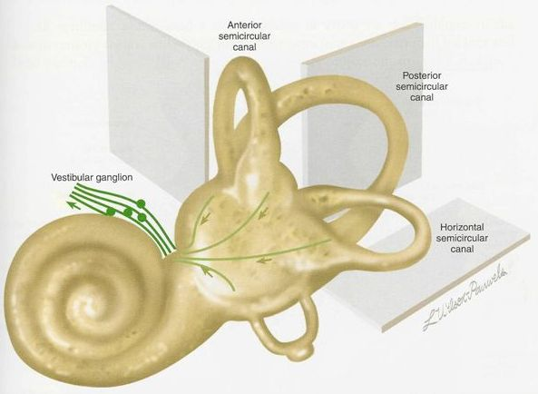
Fig. 1: Planes of the semicircular Canals. Note that they are at right angles to each other. (From Wilson-Pauwels et al.2nd Ed.2002)

Neurotransmitter released by the hair cells in the maculae and ampullae affects the peripheral processes of the primary sensory neurons whose cell bodies form the vestibular ganglion.

The central processes of the primary vestibular neurons form the vestibular component of the eighth cranial nerve. They travel with the cochlear afferents through the internal acoustic meatus to the vestibular nuclei at the junction of the pons and the medulla (Wilson-Pauwels, et al. pg.147, 2002).

The vestibular nuclei integrate signals from the vestibular apparatus with sensory input from the spinal cord, cerebellum and the visual system and coordinate motor activities involved in eye and skeletal movements (see fig. 2).
The vestibular nucleus is composed of four major subnuclei (superior, medial, lateral, and descending/inferior) sitting in the floor of the medulla at the pontomedullary junction (Wilson-Pauwels, et al. pg.148, 2002).

Input predominantly from the semicircular canals but also from the otolithic organs projects to the:

Superior and medial nuclei, which send signals in the contralateral ascending medial longitudinal fasciculus (MLF) to coordinate head and eye movements via cranial nerve nuclei III, IV, and VI. The medial nucleus also forms a substantial bilateral projection caudally to the cervical spinal cord via the descending MLF to coordinate postural head and neck movements (Wilson-Pauwels, et al. pg.148, 2002). The medial longitudinal fasciculus also coordinates head movements with eye movements (Nolte, pg.364, 2002).

Input predominantly from the otolithic organs but also from the semicircular canals projects to the:

Lateral nucleus, which projects ipsilaterally to the spinal cord mostly in the lateral vestibulospinal tract to coordinate postural responses to gravity (Wilson-Pauwels, et al. pg.149, 2002). This is the principal route by which the vestibular system brings about postural changes to compensate for tilts and movements of the body (Nolte, pg.364, 2002).

Descending (inferior) nucleus, which projects bilaterally to the cervical spinal cord by the descending MLF and to the vestibular parts of the cerebellum and other vestibular nuclei (Wilson-Pauwels, et al. pg.149, 2002).

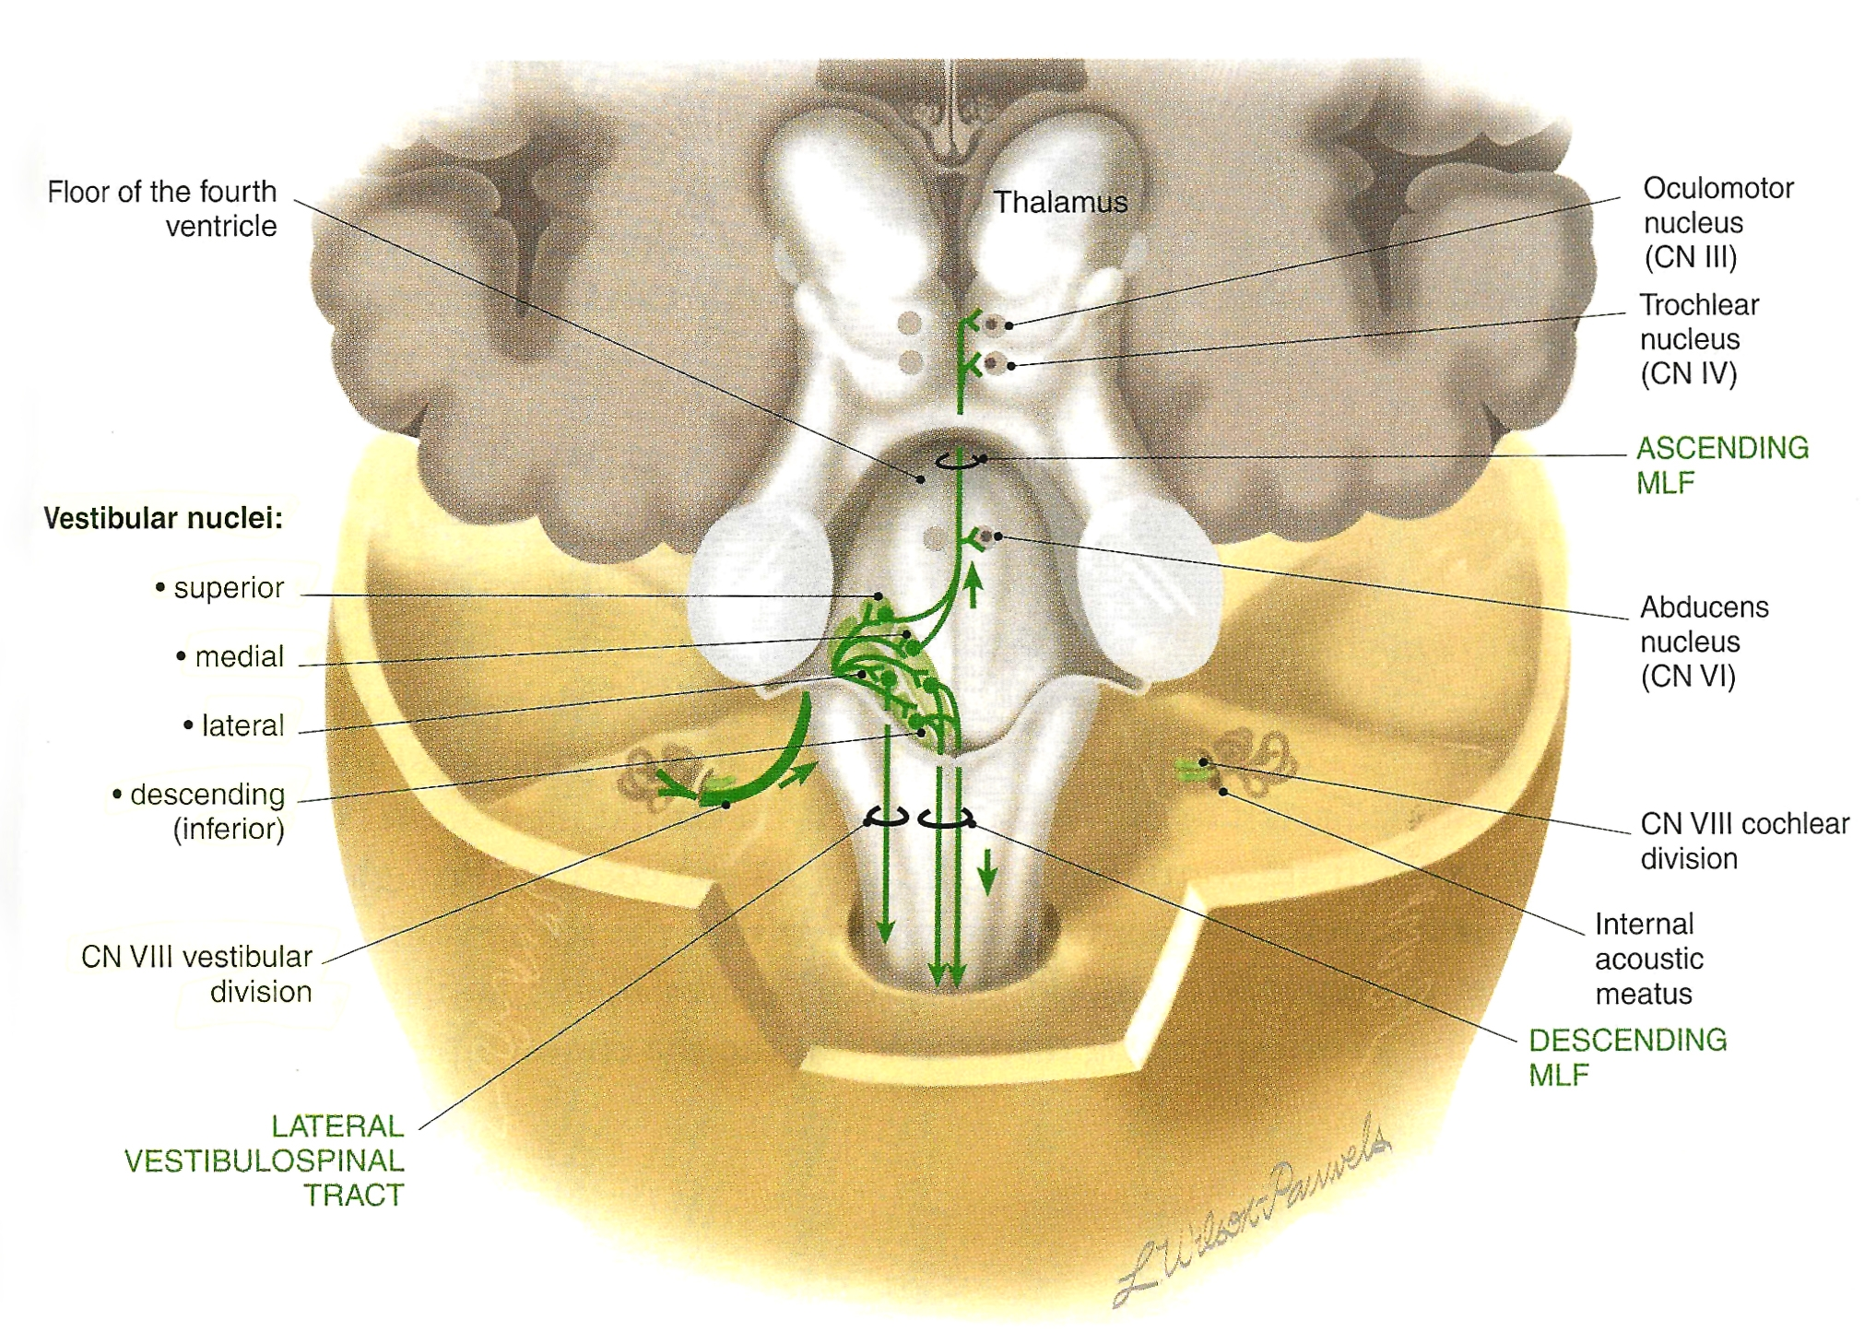
Fig. 2: Central afferent pathways of the vestibular division. Note how the MLF (medial longitudinal fasciculus) cranially leads to the oculomotor nucleus, and the Lateral Vestibular Tract caudally leads to the spinal cord.(From Wilson-Pauwels et al.2nd Ed.2002)

The vestibular apparatus and the cerebellum are very closely connected and therefore can affect each other (see fig. 3).

Paradoxial vestibular syndrome: Abnormalities of the caudal cerebellar peduncle or flocculonodular lobules may cause clinical signs more often associated with vestibular dysfunction. The head tilt however, is to the side away from the lesion.
Diseases resulting in a paradoxical head tilt tend to affect the structure of the caudal cerebellar peduncle or flocculonodular lobe (Bagley, pg.113, 2005).

The vestibulocerebellum (flocculonodular lobe) receives information from the semicircular canals and the otolitich organs, which sense motion of the head and its position relative to gravity. The vestibulocerebellar cortex also receives visual input via mossy fibers from the superior colliculi and from the striate cortex.
Pukinje neurons in the vestibulocerebellum inhibit neurons in the medial and lateral vestibular nuclei. Through the lateral nucleus they modulate the lateral and medial vestibulospinal tracts, which predominantly

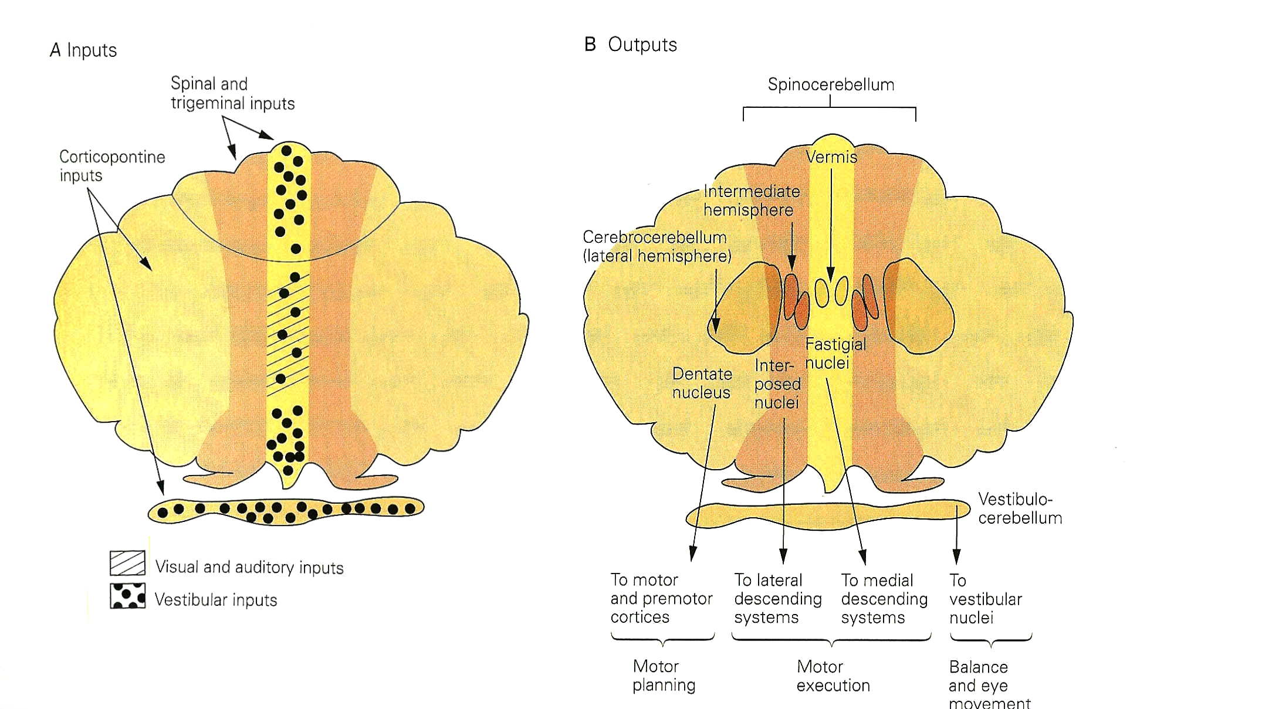
Fig. 3: Examples of the different inputs and outputs of the three functional regions of the cerebellum. (From Kandel et al. 4th Edition 2000)

control axial muscles and limb extensors, assuring balance during stance and gait. The inhibitory projection to the medial vestibular nucleus controls eye movements and coordinates movements of the head and eyes via the medial longitudinal fasciculus (Kandel et al. pg. 841, 2000)

Taking all this information into consideration, it might be realistic to think, that a puppy with a slight tilt of the head must have decreased/altered stimulation of the vestibular apparatus. The overall result is then going to be decreased stimulation of the antigravity (extensor) muscles, and the puppy will not be able to get up, therefore just staying in sternal recumbancy.

The vestibulocerebellum (flocculonodular lobe) (see Fig.4) receives input from the vestibular labyrinth and projects directly to the vestibular nuclei. The vermis receives input from the neck and trunk, the vestibular labyrinth, and the retinal and extraocular muscles. Its output is focused on the vestibulospinal, reticulospinal and to some extend also the corticospinal tracts (although it’s lesser functional in dogs than humans), which control the motor neurons of proximal muscles and limb extensors (Kandel et al. pg.840, 2000).

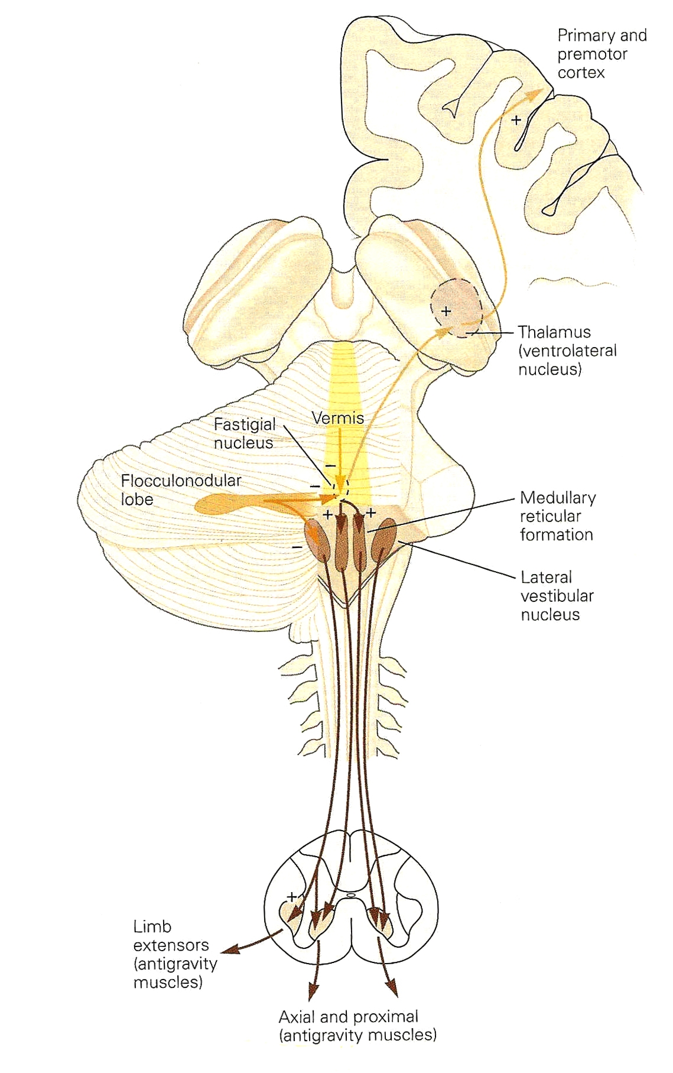
Fig. 4 The flocculonodular lobe and the vermis control proximal muscles and limb extensors. (From Kandel et al. 4th Edition 2000)

CASE REPORT:
Daisy was a 4 weeks old chocolate Labrador. She was born the eleventh of May 2007 at 10.30 am with a weight of 454 gram. She was at that moment bright alert and in very good health.
They were four puppies in the litter and two died. Only Daisy and a brother survived.
According to the owner, both parents were normal and there was no family history of swimmer syndrome or pectus excavatum.

On the tenth day, the owner noticed that Daisy had a head tilt to the right and only wanted to lay flat on the chest, paddling with her legs.

2 days later she was examined by a veterinarian, who diagnosed her as a “swimmer puppy” (pectus excavatum). During the following days Daisy was unable to move and turn around, Then on the 15th day
the owner talked to a professional breeder who instructed the owner in doing some physiotherapy with the puppy to stimulate her getting up.

On day 16 the veterinarian stopped the puppies from nursing and replaced it with supplement so that the puppies didn’t get all the medication from the milk (the bitch had been on medication for a post partum infection).
Daisy progressed each day, getting more and more extensor function, but the asymmetry of the head did not improve.

On day 22 the owner took Daisy to another veterinarian to have her treated with acupuncture. She responded with a pain reaction, but it didn’t change her head carriage or decreased extensor function.

On day 23 Daisy was brought to a third veterinarian, because the owner was concerned that she might be suffering from some kind of cerebral haemorrhage or maybe even blindness.
The veterinarian was very sure that neither was Daisy suffering from cerebral haemorrhage nor was she blind. But taking the lateral strabismus (with a perfectly normal eye) into consideration together with her head tilt and the loss of extensor tonus, he suspected some kind of neurological issue, and referred the puppy to our clinic.

On day 28, Daisy was presented at our clinic, to see if there were biomechanical problems causing the head tilt.

Upon presentation to our clinic (see fig.5), Daisy was no longer lying flat on the chest. She was able to walk a little, although she did not have the normal amount of strength and tonus in her limb muscles. When she walked around it was very obvious that she had a head tilt to the right. There was also lateral strabismus of the left eye.
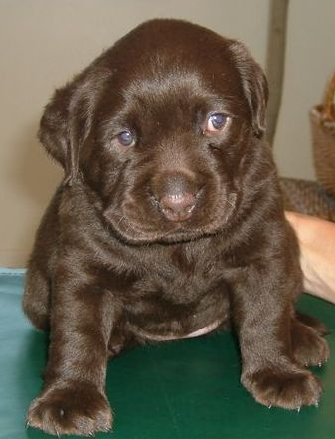
Fig. 5: Daisy at her first visit, 28 days old

The neurological examination revealed normal responses in the proprioception, dazzle, withdrawal and patellar reflexes. The menace reflex was not yet developed in such a young individual. The papillary light reflex (PLR) was normal on the right side, but slightly decreased on the left side. Daisy was not able to follow a cookie with her left eye.

Evaluating the musculature of the body, there was symmetry but a little weakness, which was to be expected so shortly after she had been a swimmer puppy.

A chiropractic examination of the spine was performed, to see if there was a normal range of motion (ROM) of the joints. It was found to be decreased in the lower cervicals to the left. Interestingly enough the range of motion was also decreased in between C1 and C2 - the joint responsible for most of the rotation in the neck - and atlas was fixed dorsally in the left side creating a head tilt to the right.

Overall theory about Daisy:
Daisy had decreased ROM in her neck. It could be from a difficult birth or the bitch that might have stepped on the neck. Neither could be verified. However, the decreased ROM in the neck created a head tilt and caused a change in the vestibular apparatus with decreased frequency of firing (FOF) in the descending motor tracts (Vestibulospinal and reticulospinal). The result was a loss of muscle tonus in the antigravity musculature of Daisy, thereby developing the swimmer syndrome. The reaction in the semicircular canals also resulted in a change in signal to the superior and medial nuclei, and as a consequence decreased FOF in the medial longitudinal fasciculus (MLF) to the cranial nerve nuclei III (oculomotor nuclei) (Wilson-Pauwels, et al. pg.148, 2002). That decreased stimulation of the oculomotor nerve caused the medial rectus musculature (which is one out of six extraocular muscles) to weaken, and that’s why she developed lateral strabismus. From human patients we know that lateral strabismus often is accompanied by diplopia (double vision) (Nolte, pg.297, 2002).

At the first consultation Daisy had a chiropractic treatment to improve the mobility in the neck, and to restore normal vestibular and cerebellar input. The atlas was adjusted ventrally and the C6-C7 to the right, in a 45-45-45 angel. The chiropractic technique used was an adaptation of the Willoughby-Rivera techniques taught at the International Veterinary Chiropractic Academy and The Healing Oasis Wellness Center.

The owner was now instructed to do the following exercises with Daisy three times a day:

1: To keep the neck movable, she should feed Daisy on the floor and also make her turn the head to both sides after a cookie. This exercise was used to stimulate the proprioceptors of the joint capsules and the MSC in the neck musculature. But when she lowers her head, reaching after the food, she also moves the jaw and by that increases the frequency of firing (FOF) to the trigeminal system.

2: To stimulate overall proprioception, she should perform passive stretch on each digit to stimulate the motor cortex and the extensor muscles. By doing passive stretch with each digit, all the joint mechanoreceptors, the MSC (muscle spindles cells) and the GTO (golgi tendon organs) sends somatosensory information through the cuneocerebellar and the spinocerebellar tracts to the spinocerebellum. This information is processed in the cerebellum and sent to the motor cortex via the neurons of the ventral lateral thalamic nucleus. These thalamic neurons project mainly to areas of the primary motor cortex, which through the corticospinal tract influence the motor neurons in the contralateral spinal cord that control the limb musculature (Haines, pg.447, 2006).

3: To stimulate the oculomotor nerve (cranial nerve III), the owner should try to put a cookie on Daisy’s nose, to make her curious and interested in the nasal visual field. This should stimulate the use of the medial rectus muscle.

4: To stimulate the V1 branch of the trigeminal nerve the owner should tap the medial eye canthus (see fig.6). The increased sensory input in the medial aspect of the head is also increasing the awareness of the motor cortex, to stimulate the muscles.

Besides all those exercises, it is also important to hold the puppy in a standing position supporting underneath the belly and try to adduct the legs because it will increase the conscious proprioception (Verhoeven G. et al. pg.2, 2006).
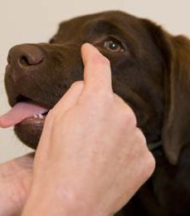
Fig. 6: How to tap the medial canthus.

The head tilt had disappeared the day after the chiropractic treatment. The lateral strabismus slowly improved day by day.

After 10-12 days only a very slight deviation was noticeable when the puppy tired.

On the 8th of August at 3 months if age, Daisy came in for a recheck. She had now been without symptoms for 1½ month and was a happy, freely movable puppy. Daisy had a complete neurological and biomechanical examination once again, to make sure that everything was as good as it appeared. All the reflexes were considered normal and she had a very well functioning body.
However, as Daisy is still growing, it is very important to follow her way of improving. Therefore the owner has agreed to come back for another recheck in about six month.

DISCUSSION:
Daisy is only one single case out of many thousand. Since swimmer puppy syndrome is not a rare condition/disorder, many would say that it’s therefore not so satisfying to look at her only. But she is only an example to illustrate all the well known observations we have.

Besides being a swimmer puppy, Daisy also had a head tilt and lateral strabismus, which is not the case in most swimmer puppies. But as

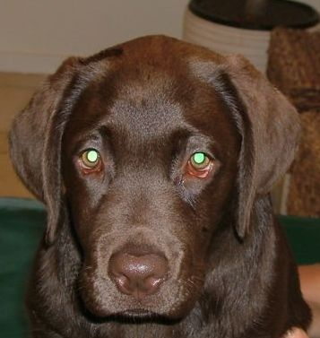
Fig. 7: Daisy 3 month old. Note the symmetri of her head and eyes.
many other diseases, swimmer puppy syndrome might fit into different categories dependent on the severity.
No matter what level of symptoms, it is always the same observations we have on swimmer puppy syndrome, and that’s why it is possible to make some overall conclusions, even though Daisy is a single case.

The observations:
- symptoms may start when the puppy is only few days old, but also in weeks old puppies.
- an affected puppy is only seen in small litters
- it’s only one puppy per litter which is affected
- are seen in puppies which has a tendency to be obese
- are overall that they remain in sternal recumbency
- the affected puppy is paddling with the front legs with the hind legs trailing behind
- the affected puppy nurses with the head to the same side every time
- the degree of pectus excavatum is dependent on how long the puppy stay in sternal recumbency
- the best result comes when the owner does some physiotherapy with the puppy and/or tapes the legs together in a way so they are stabilized.

Other possible clinical signs include: dyspnea, dysphagia, constipation and skin ulceration (Verhoeven G., et al. pg.5, 2006)

The cause of the disorder has been hypothesed to be:

- genetic (inherent)
- nutritional deficiency
- environmental (flat hard surface, bacteria, viruses and so forth.)
- delayed development of the myelin sheaths
- neuromuscular disorder

If it is a genetic disorder, then how is it inherited and why is only one puppy in the litter affected? Even though the bitch has been bred several times the syndrome is rarely seen more than once per bitch. Therefore we have no evidence to conclude that it is inherited or genetically related.

Neither is nutritional deficiency likely to be the cause. Again it is only one puppy per litter with a tendency to be overweight. Interestingly, it is often top professional breeders who very well know how to feed the pregnant bitch. Even the food companies (Royal Canin), who have investigated swimmer puppy syndrome according to deficiency in nutrition, have concluded that it has no relation to nutrition (publications.royalcanine.com).

Environmental problems are highly unlikely to cause the syndrome, once again because it’s only one puppy per litter and that litter bred by top professional breeders. Of course, it’s harder to stand up on a flat hard surface if the puppy has decreased extensor tonus in the muscles, but apart from that there is nothing in that hypothesis which can explain the swimmer puppy syndrome.

Up to now there have been no logical explanations as to how a delayed development of the myelin sheaths would cause swimmer puppy syndrome. So until we know more about which nerves and tracts should be affected or until someone is able to explain why some nerves have a delayed development and others not, this hypothesis should be rejected too.

By exclusion, a neuromuscular disorder therefore seems to be the most likely cause. This cause is probably or at least in most of the cases, a dysfunction in the neck creating a dysfunction in the vestibular apparatus. The reason why we find an affected puppy only in small litters must be that, when there are fewer puppies their birth weight is increasing. That can result in lack of intrauterine space (Vanhoeven G., et al. pg.5, 2006) and/or making them more likely to be involved in dystochia. When the puppy is getting stocked into the birth canal, the push from the labour or the pull in the puppy from outside must sometimes create a fixation in the neck of the puppy. We are not able to observe this fixation right away because the puppy has not yet developed the secondary lordortic curve in the cervicals.
Another important factor in the fact that it is almost always obese puppies that develop the swimmer syndrome is, that the more weight you put on weak muscles, the harder it is to stand.

Even if it is only to a minor degree the owners can do some physiotherapy with the puppy to stimulate the motor cortex and thereby the extensor muscles, this therapy will often be able to resolve the symptoms very well. In mild cases and early in the course, that therapy might be enough to regain the full neuromuscular function.

The breeders are doing all that work with the puppy, because they don’t want to let go of the puppy, and they know that it is helping. They just don’t know why they are doing such a great a job.

So if the veterinarians know the pathophysiology and educate the breeders/owners well in how to do the exercises, we might be able to save almost all the swimmer puppies.

In the severe cases where the puppy has any kind of dysfunction and/or head tilt after the swimmer puppy syndrome had resolved (or at the same time), it’s just very important to remember that it might need a chiropractic examination combined with the physiotherapy.

So in swimmer puppies we have a category of patients where it is not a vestibular dysfunction which creates a head tilt. But a decreased range of motion in the neck that leads to various degrees of head tilts, and by that to a dysfunction in the vestibular apparatus as a cause for the swimmer puppy syndrome.

Up to now this is the only hypothesis which from a neurological view explains quite well not only what the cause of the syndrome is, but also why all the owners who do some physiotherapy have such a great impact on the outcome of the puppies.

REFERENCES:

1. BAGLEY, RODNEY S. : Fundamentals of Veterinary Clinical Neurology. Ames, Iowa: Blackwell Publishing, 1st. Edition, 2005.

2. HAINES, DUANE E. : Fundamental Neuroscience for Basic and Clinical Applications, Philadelphia: Elsevier Churchill Livingstone, 3rd. Edition, 2006.

3. KANDEL, ERIC R, JAMES H. SCHWARTZ AND THOMAS M.JESSEL:The Principles of Neural Science. New York: McGraw-Hill: 4th. edition, 2000.

4. NOLTE,JOHN: The Human Brain. St.Louis: Elsevier Mosby, 5th. Edition, 2002.

5. PURVES,DALE, AUGUSTINE,GEORGE J. , FITZPATRICK, DAVID , HALL, WILLIAM C. , LAMANTIA, ANTHONY-SAMUEL, McNAMARA, JAMES O. , WILLIAMS ,S.MARK : NEUROSCIENCE. Sunderland, MA: Sinauer Associates, Inc: 3rd. Edition, 2004.

6. VERHOEVEN G., DE ROOSTER, H, RISSELADA M., WIEMER P., SCHEIRE L. AND VAN BREE H. : Swimmer syndrome in a Devon rex kitten and an English bulldog puppy. Journals of small animal practice vol. 47, 2006.

7. WILSON-PAUWELS, AKESSON, STEWART AND SPACEY: CRANIAL NERVES in health and disease. Hamilton Ontario: BC Decker Inc: 2nd. Edition, 2002.

